Attention: _________________ COMPANY: _______________________ Number _______________

Notes: _________________________________________________________ PAGE ___ OF _____

_________________________________________________________

_________________________________________________________

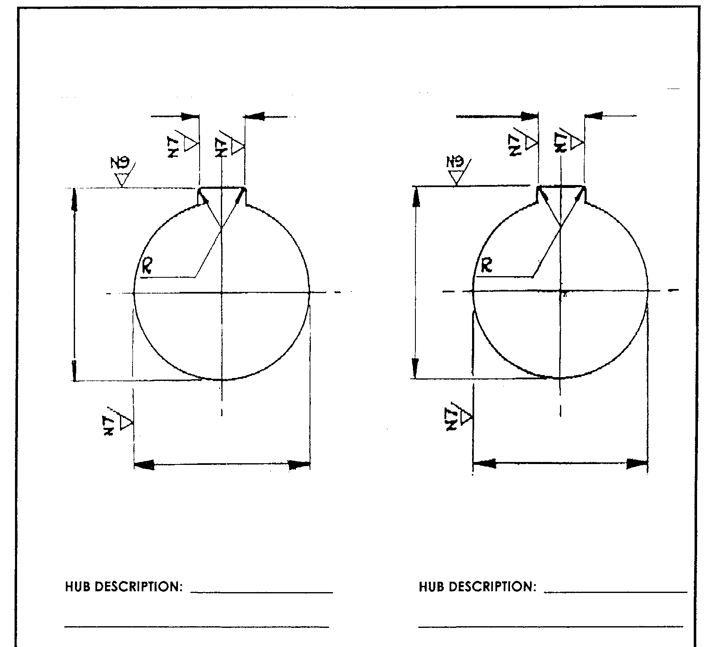

SHAFT DIAMETER: _____________________ SHAFT DIAMETER: __________________

**BAY TRANSMISSION SERVICES cc – Bore & Keyway Dimensions**

Job Description: ________________________________________________

_________________________________________________

SENT BY: ____________________ DATE SENT: _____________

I/WE HEREBY AGREE THAT THE DETAILS ON THE ABOVE DRAWING ARE FIXED AND FINAL AND ANY EXPENSES INCURRED DUE TO MODIFICATIONS HEREAFTER WILL BE TO MY/OUR ACCOUNT.

Signed: _________________________ Date: ________________________

Name: _________________________ Title: ________________________

Company: __________________________________________________________________